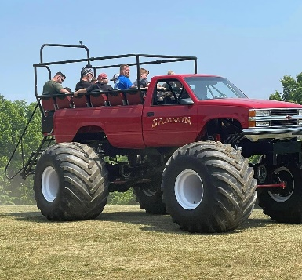

SAMSON MONSTER TRUCK MAIL IN MERCHANDISE ORDER FORM

To order by mail print this form and provide the following info -

ITEM | SIZE | QUANTITY | PRICE | TOTAL

Shipping & Handling Charges **
Allow 2 weeks for delivery

$20 or Less ……………………………….. $12
$21 - $50 ………………………………….. $15
$51 - $75 ………………………………….. $20
$76 - $100 ………………………………… $25
Ohio residence only – add 7.50% State Sales Tax

** WE DO NOT SHIP TO ALASKA, HAWAII, CANADA or INTERNATIONALLY **

Subtotal | $
Ohio Sales Tax 7.50% | $
Shipping/Handling | $
Order Total | $
Name
Address
City
State
Zip
Contact Number

Mail order form with Check or Money Order made payable to Dan Patrick Enterprises Inc.

Dan Patrick Enterprises Inc.
Christine Patrick
8564 Zane Trail Rd.
Circleville, Ohio 43113

If paying by credit card please furnish -
Credit Card # -
Expiration Date -
3-digit Security Code -
Billing name & address of the card -
*If you wish to contact me by phone with cc info: 740-477-1006

Thank-you!

Christine Patrick
740-477-1006
samson1@samson4x4.com

